

FAKE NEWS DETECTION USING MACHINE LEARNING TECHNIQUES

Golden Gate University, San Francisco, USA
  - Submitted by:
Mohammed Dastagir
  - GGU ID: GGUDBA62638
  - Course: DATA110, Introduction to Python using Machine Learning
  - Under the guidance of:
Dr. Durga Sharma
April 2026

Abstract
Fake news detection has become an important problem in today’s digital era due to the rapid spread of misinformation through online platforms. This study focuses on classifying news articles as fake or real using machine learning techniques. The dataset consists of textual features such as news title, content, and subject.
Data preprocessing techniques, including text cleaning and transformation using TF-IDF, were applied before model development. Multiple classification models, such as Logistic Regression, Decision Tree, Random Forest, and Artificial Neural Networks (ANN), were implemented and compared. The models were evaluated using accuracy, precision, recall, and F1-score.
The results show that Random Forest achieved the highest accuracy of 99.70%, followed by Decision Tree (99.43%), ANN (99.02%), and Logistic Regression (98.67%). The findings indicate that ensemble learning methods are highly effective for text classification tasks.
Keywords: Fake News Detection, Machine Learning, NLP, Random Forest, Classification

1. Introduction
Fake news detection has become a significant area of research in recent years due to the rapid growth of digital media and online communication platforms. With the increasing use of social media and online news sources, people rely heavily on digital platforms for information. However, this has also led to the widespread dissemination of misinformation, commonly known as fake news. Fake news refers to false or misleading information presented as legitimate news, which can influence public opinion and create confusion in society (Shu et al., 2017).
The impact of fake news is evident across multiple domains, including politics, healthcare, and economics. During elections, fake news can manipulate voter behavior, while in healthcare, misinformation can lead to harmful decisions (Zhou & Zafarani, 2018).
Traditional methods such as manual fact-checking are time-consuming and inefficient. Machine learning (ML) and natural language processing (NLP) provide automated solutions by analyzing textual data and identifying patterns (Rashkin et al., 2017).
Models like Logistic Regression, Decision Trees, and Random Forest are widely used for classification. Random Forest improves performance by combining multiple trees (Breiman, 2001). Artificial Neural Networks (ANN) can capture complex nonlinear patterns (Goodfellow et al., 2016).
This study aims to develop a machine learning model to classify news as fake or real. It includes preprocessing, EDA, model building, and evaluation. The goal is to identify the best-performing model and demonstrate the effectiveness of ML in fake news detection.

2. Data Description
The dataset used in this study consists of fake and real news articles obtained from Kaggle (Bisaillon, 2020). It contains approximately 45,000 records.
The dataset includes the following variables:
- Title: Headline of the news article
- Text: Main content
- Subject: Category of the news
- Date: Publication date
- Label: Target variable (0 = Fake, 1 = Real)
The data is unstructured text, requiring preprocessing before use. The dataset is relatively balanced, making it suitable for classification tasks.

3. Methodology
  - 3.1 Data Pre-processing
Text data was cleaned by:
- Converting to lowercase
- Removing punctuation and numbers
TF-IDF was used to convert text into numerical form. The dataset was split into training (80%) and testing (20%).

  - 3.2 Exploratory Data Analysis (EDA)
EDA was performed using:
- Bar charts (class distribution)
- Histograms (text length)
These helped me understand patterns and ensure data quality.

  - 3.3 Model Development
The following models were implemented:
- Logistic Regression
- Decision Tree
- Random Forest
- Artificial Neural Network (ANN)

  - 3.4 Evaluation Metrics
Models were evaluated using:
- Accuracy
- Precision
- Recall
- F1-score

4. Results & Discussion
Model Performance
Model | Accuracy
Logistic Regression | 98.67%
Decision Tree | 99.43%
Random Forest | 99.70%
ANN | 99.02%
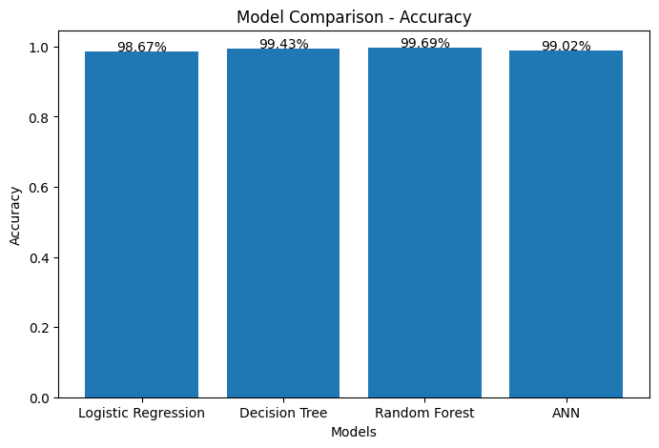
The bar chart shows the comparison of different machine learning models based on accuracy. Random Forest achieved the highest accuracy, followed by Decision Tree and ANN. Logistic Regression showed slightly lower performance compared to other models.

Figure 2: Confusion Matrix
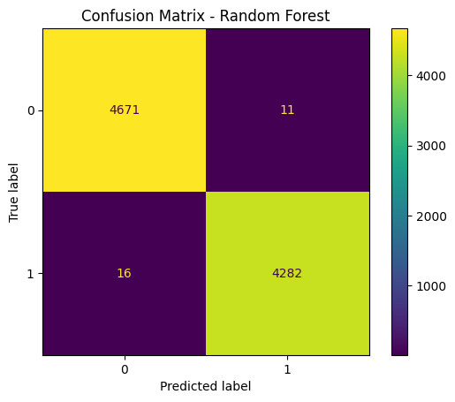
The confusion matrix shows the performance of the model in terms of correct and incorrect predictions. The diagonal values represent correctly classified instances, while the off-diagonal values represent misclassifications. The results indicate that the model has very high accuracy with minimal errors in classification.

Figure 3: ROC Curve
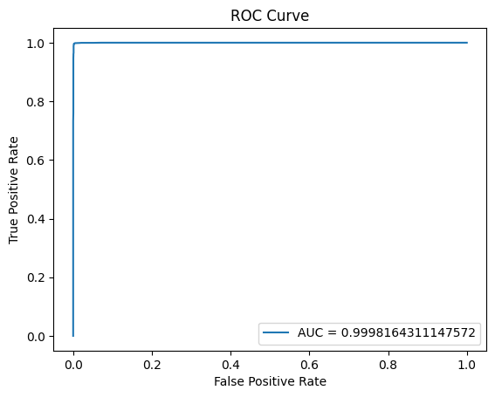
The ROC curve represents the performance of the classification model by plotting the true positive rate against the false positive rate. The curve is close to the top-left corner, indicating excellent model performance. The high Area Under the Curve (AUC) value shows that the model can effectively distinguish between fake and real news.
  - Interpretation
All models performed extremely well. Random Forest achieved the highest accuracy (99.70%), making it the best model. Decision Tree and ANN also performed strongly.
Random Forest performs best due to ensemble learning, which reduces overfitting and improves prediction accuracy.

Graph Interpretations
Confusion Matrix:
Most predictions are correct, with very few errors.
ROC Curve:
Curve close to top-left indicates excellent performance.
Scatter Plot:
Predicted values closely match actual values.

  - Key Findings
- Random Forest performed best
- ANN captured complex patterns.
- Logistic Regression had slightly lower accuracy
- Ensemble learning improves performance.

Limitations
- Only text data used.
- Possible overfitting due to high accuracy
- Limited feature engineering

5. Conclusion
This study demonstrates the effectiveness of machine learning in detecting fake news. Multiple models were implemented and compared, including Logistic Regression, Decision Tree, Random Forest, and ANN.
Random Forest achieved the highest accuracy of 99.70%, making it the most effective model. The results highlight the importance of ensemble learning and proper preprocessing in improving model performance.
The project shows that machine learning can successfully solve real-world problems like fake news detection and help reduce misinformation.
Future improvements can include deep learning models such as LSTMs and BERT, as well as real-time data integration.

References (APA Format)
- Breiman, L. (2001). Random forests. Machine Learning, 45(1), 5–32.
- Géron, A. (2022). Hands-on machine learning with Scikit-Learn, Keras, and TensorFlow (3rd ed.). O’Reilly.
- Goodfellow, I., Bengio, Y., & Courville, A. (2016). Deep learning. MIT Press.
- Shu, K., Sliva, A., Wang, S., Tang, J., & Liu, H. (2017). Fake news detection on social media.
- Zhou, X., & Zafarani, R. (2018). Fake news detection: A survey.
- Bisaillon, C. (2020). Fake and real news dataset. Kaggle.

Thank you

